**Weekly Status Report - 2018-MAY-29**

|  |  |
| --- | --- |
| **Project Name** | BiFrost Games |
| **Team Lead** | Devan Weber |

|  |  |  |  |
| --- | --- | --- | --- |
| **Roles** |  |  |  |
| **Week** | **<Pat Horler>** | **<Curtis Naples>** | **<Evan Plant>** |
| 01 | Project Lead, Technical Writer | Technical Writer | Technical Writer |
| 02 | Technical Writer, SQL | HTML, SQL | SQL |
| 03 | Front-end Dev, Middleware Dev | Front-end Dev, Middleware Dev | Team Lead, Database Dev, Middleware Dev |
| 04 |  |  |  |
| 05 |  |  |  |
| 06 |  |  |  |
| 07 |  |  |  |
| 08 |  |  |  |

|  |  |  |
| --- | --- | --- |
| **Roles** |  |  |
| **Week** | **<Devan Weber>** | **<Illia Kara>** |
| 01 | Technical Writer | Technical Writer |
| 02 | Project Lead, SQL | SQL |
| 03 | Front-end Dev, Middleware Dev | Middleware Dev |
| 04 |  |  |
| 05 |  |  |
| 06 |  |  |
| 07 |  |  |
| 08 |  |  |

|  |
| --- |
| **Weekly Project Summary** |
|  |

|  |  |  |  |  |  |
| --- | --- | --- | --- | --- | --- |
| **Key Milestones Status** | | | | | |
| **ID** | **Description** | **Planned Completion** | **Forecasted**  **Completion** | **Actual Completion** | **Status** |
| MS01 | BRD Complete | Week 2 | Week 2 | Week 2 | Complete |
| MS02 | Git Workflow Setup | Week 2 | Week 2 | Week 2 | Complete |
| MS03 | Database Setup | Week 2 | Week 2 | Week 2 | Complete |
| MS04 | HTML/CSS Header Template Complete | Week 2 | Week 2 | Week 2 | Complete |
| MS05 | “Add Products” Page Working | Week 3 | Week 3 | TBD | Mostly Complete |
| MS06 | Main Product Display Page Working | Week 3 | Week 3 | Week 3 | Complete |
| MS07 | Users Can Create an Account and Sign-in (Including Admin Accounts) | Week 4 | Week 4 | TBD | Incomplete |
| MS08 | Users Can Add Products to Cart and View Them | Week 4 | Week 4 | TBD | Incomplete |
| MS09 | Customer Can Remove/Edit Products In Their Cart | Week 4 | Week 4 | TBD | Incomplete |
| MS10 | Contents of Shopping Carts Persist Across Sessions and Devices | Week 4 | Week 4 | TBD | Incomplete |
| MS11 | A Confirmation email is Sent to A Customer After They Place an Order | Week 5 | Week 5 | TBD | Incomplete |
| MS12 | The Online Payment Process Occurs at Checkout | Week 5 | Week 5 | TBD | Incomplete |
| MS13 | Customers Can View Their Order History | Week 6 | Week 6 | TBD | Incomplete |
| MS14 | Website Has a Consistent Look and Feel | Week 6 | Week 6 | TBD | Incomplete |

|  |
| --- |
| **Key Accomplishments for the Week** |
| * Users Can Create an Account and Sign-in (Including Admin Accounts) * Users Can Add Products to Cart and View Them * Customer Can Remove/Edit Products In Their Cart * Contents of shopping cart persists across sessions and devices |

|  |  |  |  |
| --- | --- | --- | --- |
| **Task Assignments for the Coming Week** | | |  |
| **ID** | **Description** | **Assigned To** | **On Schedule** |
|  |  |  |  |
|  |  |  |  |
|  |  |  |  |
|  |  |  |  |
|  |  |  |  |
|  |  |  |  |
|  |  |  |  |

|  |  |  |
| --- | --- | --- |
| **Task Completed in the Previous Week** | |  |
| **ID** | **Description** | **Assigned To** |
| T17 | Sign-up template | Evan |
| T18 | Sign-in template | Curtis |
| T19 | Account sign-up available | Curtis, Pat |
| T20 | Users can sign-in to account(incl. admins) | Devan, Evan |
| T21 | Shopping cart template | Curtis, Pat |
| T22 | Users can add products to shopping cart | Evan |
| T23 | Users can view items in their shopping cart |  |
| T24 | Deliverables ready |  |
| T25 | Demo ready |  |

|  |  |
| --- | --- |
| Issues and Risks |  |
| **Description** | **Impact**  **(L,M,H)** |
| Illia not showing up for group work and classes | M |
|  |  |
|  |  |

|  |
| --- |
| **Gantt Chart** |

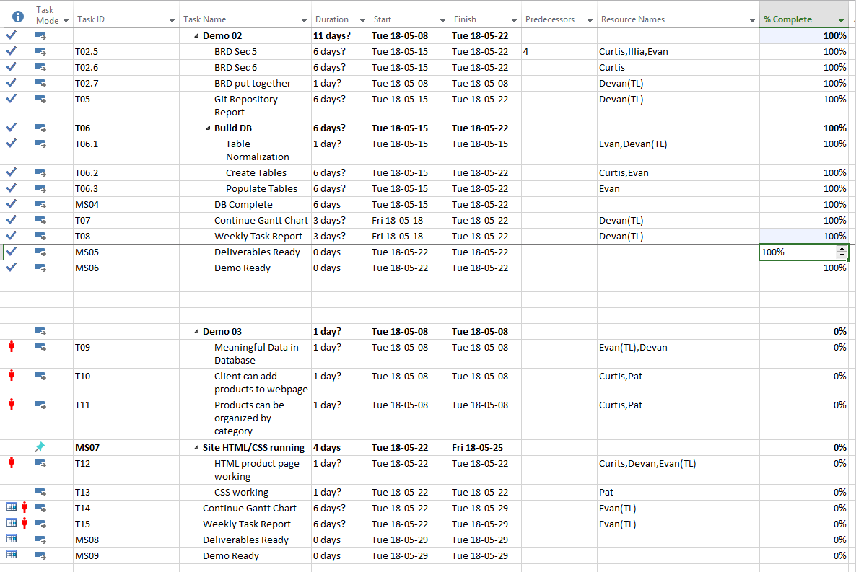

|  |
| --- |
| **Git Log** |

*< Insert Git Log here, use the following command*

*git log --since=1.week --pretty=format:"%an: %s"*

*>*

